Developing a theory of change with a biodiversity focus

A guide to take you through the steps for creating or adapting a Theory of Change (ToC).

**Acknowledgements**

This content was created by Fauna & Flora for external audiences with support from Margaret A. Cargill Philanthropies. *Last update 2025*

**Contents**

**Contents** 2

**What is this guidance?** 3

Who is this for? 3

Overview of the ToC process 3

ToC Review decision tree 4

ToC Development decision tree 5

**Stage 1: Understand the team’s initial vision of success and the scope of the project** 6

What does success look like for the project? 6

Define key species 7

Define the key habitats and ecosystem 8

**Stage 2b: Analyse the wider context** 9

**Stage 3: Map stakeholders** 13

**Stage 4: Assess team and understand external factors** 14

**Stage 5: Understand the threats and problems** 16

Map out the direct threats to each of the project’s key species or habitats/ecosystems. 16

What's driving each of these direct threats? 17

How significant is each of these threats to your biodiversity target? 18

**Stage 6: Develop a solution tree** 20

**Stage 7: Develop a Theory of Change diagram and narrative** 22

**Review and update a ToC** 24

**Simplifying a ToC** 26

**References** 27

**What is this guidance?**

Who is this for?

The main audiences for this guidance are:

* **Project teams** working to develop Theory of Change (ToCs).

***Definitions of terms:***

**Project team** – Anyone that is working directly on the project

**Key partners** – Any external organisations you are working with and who are influential within the project

**Discussion Leader** – A neutral person to lead discussions. This does not need to be the leader of your organisation/project, but does need to be someone who can remain neutral during discussions.

**Scribe** – Someone to write down the thoughts and ideas during each meeting. The scribe can write down their own notes or fill in and follow the resource document.

**Cross-cutters** – People within your organisation with expertise on specific themes/issues related to your project.

**External experts** – People who know the local context – can include local community. They should be able to provide insight on particular issues within the project area.

**Why is Theory of Change important?**

A theory of change is a method used to explain how a given intervention is expected to lead to specific results and development change. It states clearly the aims of the project and the rationale behind the aims. It helps to identify the underlying assumptions and risks that will be essential to understand and revisit throughout your project process to ensure that the proposed approach will lead to the desired change.

Theory of Change documents are a useful basis for developing fundraising proposals, and for providing an overview of the project to anyone who might need it and to help retain this information over the long term (e.g. Management and new starters).

Overview of the ToC process

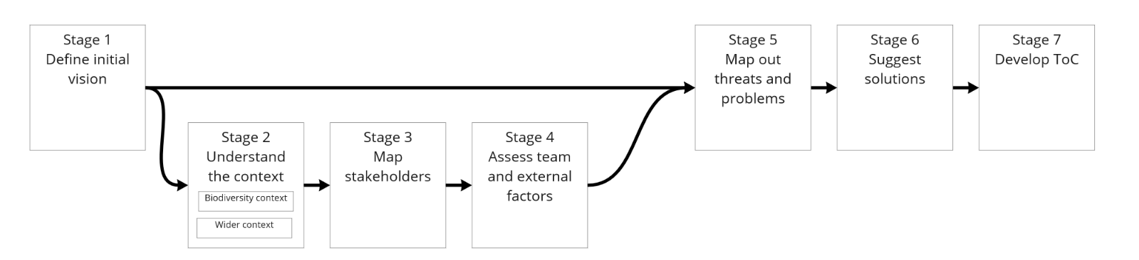

ToC Review decision tree

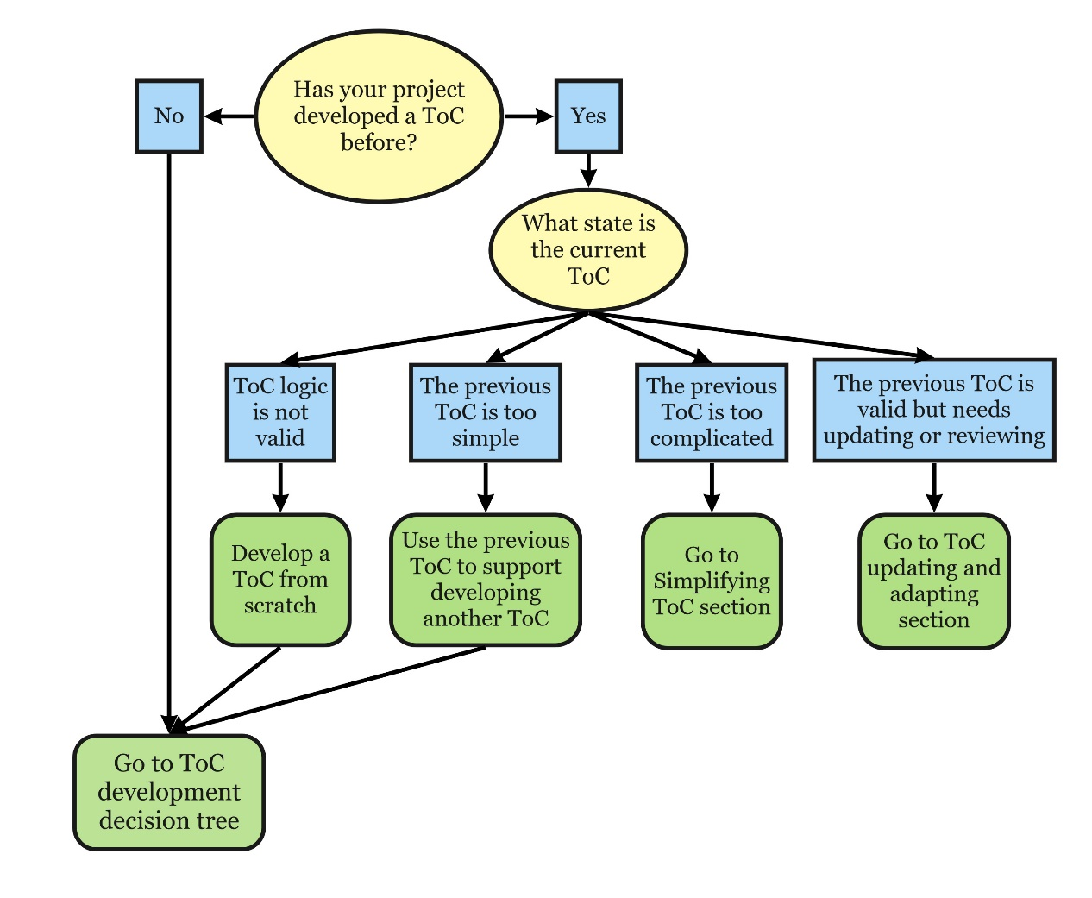

ToC Development decision tree

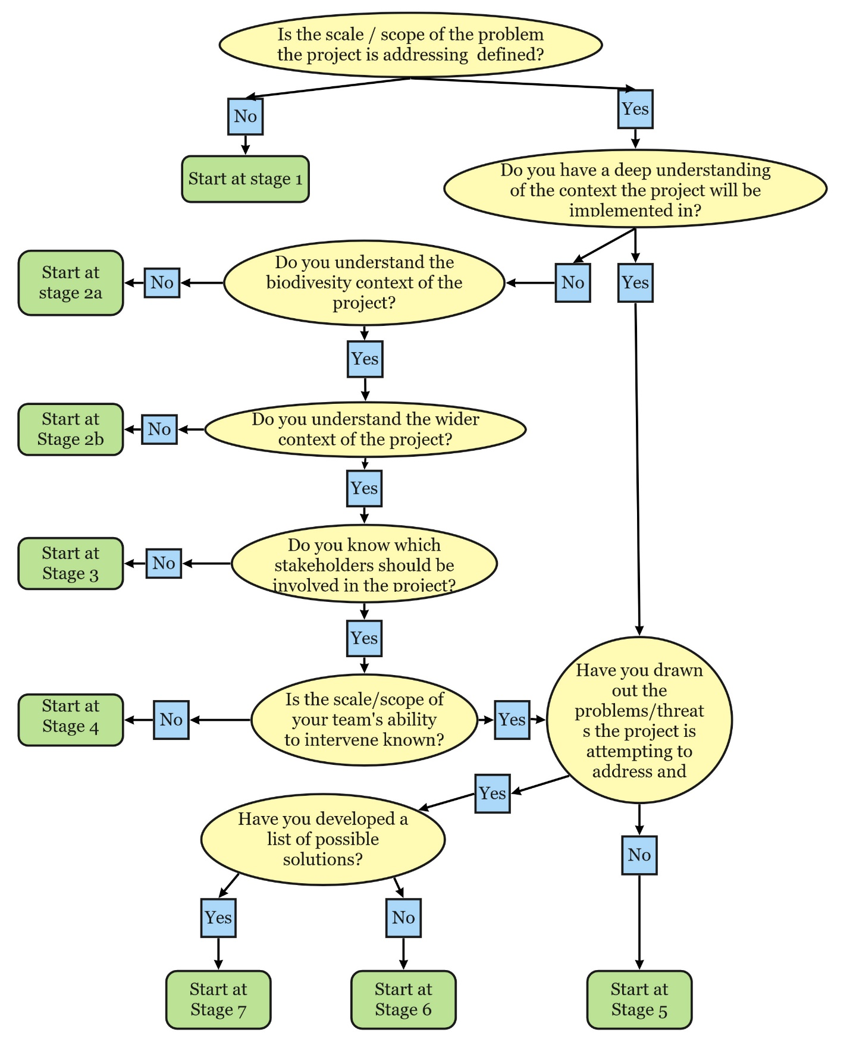

**Stage 1: Understand the team’s initial vision of success and the scope of the project**

*Aim:*

To build consensus within the team about what is important to achieve success.

*Output at end of stage:*

* A broad statement of the potential vision for the project, that everyone in the room is comfortable with.

*Who should be involved?*

* Project team and key partners
* Discussion Leader
* Scribe

What does success look like for the project?

Discuss within the team how different members understand what they would like the world to be like once the project is ended.

1. Ask participants to draw/write their vision of project success

*Questions you can ask everyone:*

* + *What end point is your project aiming for?*
  + *What is the main conservation problem you are seeking to tackle?*
  + *What is the scale or scope of the project? What is appropriate for the resources the project is likely to have?*
  + *Are you focussing on any specific habitats or species?*
  + *How long would the change you’re talking about take?*

1. Ask each participant to explain their vision to the group.
2. Group the elements that make up the vision and work to determine if any of the factors are prerequisites (something required beforehand as preparation) to the vision rather than part of the vision itself
3. Write down the vision statement and stick it somewhere everyone can see

**Stage 2a: Understand the biodiversity context**

*Aim:*

To build an understanding of the current biodiversity context in the area the project is going to work in.

*Outputs at end of stage:*

* A list of key species, habitats or ecosystems
* A map of where key species, habitats or ecosystems are

*Who should be involved?*

* Project team & key partners
* Discussion Leader
* Scribe

*Process:*

Does your project focus on individual species or the ecosystem/habitat as a whole, or both?

* If you will focus on particular species, only complete the ‘define key species’ section
* If you will focus on the ecosystem or a habitat, only complete the ‘define the key habitats and ecosystem’ section
* If you are focusing on species and the ecosystem, complete both sections.

Define key species

It is important to note that the expectation is not to do this for every species found on the site. Only do this step for the key species.

**Definition of a key species:**

A species or group of species that a project is focused on protecting.

As a team, discuss which species potentially could be of interest to the project. Then list the following:

* Is anyone else or any other organisation working on with this species?
* Where are they found?
  + Is this area protected?
  + If so, who is responsible?
* What kinds of habitats are they found in?
* What key threats to that species are there?
* How does their life history relate to your area the geography (resident, transient, key for certain life cycle elements such as breeding, feeding, birthing)
* How many are there? In the world and within your area.
* What do they eat? Or if it is a plant, how are they pollinated?
* What is their reproductive age?
* Do they have particular behavioural traits?
* **What is their protection status in your area?**
* Are these species harvested or used by people?
  + If so, who by?
  + Are they important for local livelihoods?
* Are there any cultural values related to these species?

If questions cannot be answered by anyone during the meeting, give everyone one or two questions to research, find the missing information and bring it to the next meeting.

Define the key habitats and ecosystem

In your team, discuss which habitats and ecosystems potentially could be of interest to the project, and research the following:

* Is anyone else or another organisation working on this?
* What are the key ecosystem features? E.g. biotic or a biotic factors?
* What key threats to that habitat or ecosystem are there?
* Are there different habitat types that are important for biodiversity? If so, where are they?
* Do these places provide particular ecosystem services?
* Is the area under any form of protection?
  + What are the boundaries?
  + Who is responsible?
* What is the land or sea tenure arrangements for the site(s)?
* Are there jurisdictional boundaries that affect the area?
* How are the habitats or ecosystems used? Who by?
* Are there any cultural values placed on the site?

If questions cannot be answered by anyone during the meeting, give everyone one or two questions to research, find the missing information and bring it to the next meeting.

**Stage 2b: Analyse the wider context**

*Aim*

To build understanding of the non-biodiversity related context the project is working within.

*Outputs at end of stage*

* A list of considerations from the wider context that may affect the design and implementation of the project.

*Who should be involved?*

* Project team
* External experts
* Cross-cutters
* Discussion Leader
* Scribe

*Process:*

The context that your project will be working in should be analysed early on in the design of a project.

Questions to consider when analysing the context can be split into six areas:

* Political
* Economic
* Social
* Technological
* Legal, and
* Environmental

***Political*** *- How might the government and/or other political factors impact your project?*

* What government policies or political groups could be beneficial or detrimental to the project?

Note: it is important to think about different scales of government in your particular context – national, regional, district, municipal, village etc.

* Is the political environment stable or likely to change?
  + When is the next local or national election?
  + Who are the most likely contenders for power?
  + How might this change policies and affect the project?
* Who are your key government stakeholders?
  + Do you have an existing relationship with them, and if so, what is this relationship like?

***Economic*** *- What is the economic climate nationally / internationally?*

* What economic factors could impact the project moving forward?
* What types of livelihood strategies do people who might be impacted by your project engage in?
  + Is there variability based on time of year?
  + Is there a time of year when people experience greater livelihood vulnerability?
  + How does this impact people?
* How stable is the current economy?
  + Is it growing, stagnating or declining?
  + How is globalisation affecting the economic environment?
* Are the key exchange rates stable or do they tend to vary significantly?
* What is the unemployment rate?

***Social*** *- How might different social factors impact your project?*

* Are there different ethnic groups within the population?
  + Do different ethnic groups have different levels of political influence?
  + Do different ethnic groups have different values and interests in the environment?
  + Are there any considerations about which groups the project engages with and how?
* Are there any Indigenous Peoples in the project area?
  + If so, how will they be engaged, and how could the project impact them (positively and negatively)?
* Are there vulnerable or historically marginalised groups (including unregistered peoples) in the project area?
  + How could these groups be impacted (positively and negatively) by the project?
  + What steps will the project take to engage with these peoples and ensure their perspectives and values are heard and accounted for?
* What is the population’s growth rate and age profiles?
  + How likely is this to change?
* Are generational shifts in attitude likely to affect the project?
* What are the society’s level of health, education and social mobility?
  + How are these changing? What impact does this have?
* What are the attitudes and perceptions towards different work and livelihood activities?
  + Are these different for different members of the population (age, gender, ethnicity, class, educational status etc.)
* What social attitudes and social taboos could affect the project?
* Have there been recent socio-cultural changes that might affect this?
* What religious and spiritual beliefs and lifestyle choices do you need to consider?
  + How might these affect your project?
* Are there non-monetary values associated with resource-use and livelihoods?
* What are gender roles and relations, including for uses and value of natural environments?

***Technological*** *- What innovations and technological advances are available or on the horizon?*

* How could this affect your project and operations, positively and negatively?
* Do you avoid using technology? Why?
* Do any of your peers/stakeholders/competitors have access to new technologies that could affect the implementation of the project?
* Have infrastructure changes affect your project?

***Legal*** *- What regulations and laws are relevant to your project nationally and internationally?*

* Are there any changes to legislation that will happen in the next 2-4 years?
* Do people in or near the project area have tenure (including customary) and resource-use rights that determine the conditions for access, use, and management of the environment?
* How widespread are corruption and organised crime?
  + How are these situations likely to change and how is that likely to affect the project?
* What is the likely timescale of any proposed legislative changes?
  + Is there an opportunity for the project to influence or be involved in this?
* How do you ensure you are compliant with relevant laws?
* Could any pending legislation or taxation changes affect the project, positively or negatively?
* How does the government approach Corporate Social Responsibility, environmental issues, corporate policy and customer protection legislation?
  + What impact does this have and is it likely to change?

***Environmental*** *- How does the physical environment affect the project?*

* Are there any ways the environment might influence the success of the project?
* Are there natural resources in the project area that people rely on for their livelihoods?
  + What is the condition of these?
* What are the effects of climate, weather or geographical location on the project?
  + How will climate change or natural disaster impact the project now and in the future?
* Are your prepared for future local/national and global environmental targets or laws?
* Could the project negatively impact the environment in any way?
  + How do you mitigate this or stay aligned to what you believe in?
* How can you source, trade and test your products in an environmentally conscious way?

**Stage 3: Map stakeholders**

*Aim*

The aim of this stage is to understand:

* Who could be affected by the project (negative/positive)?
* Who else is working to tackle these threats and barriers? What are they doing?
* Who are the other influential stakeholders?

*Outputs at end of stage*

* List of key stakeholders with understanding of their influence and stake in the project’s activities and impact.

*Who should be involved?*

* Project team
* External experts
* Discussion Leader
* Scribe

*Process*

**Step1: Brainstorm the different stakeholders in your project.**

A stakeholder is a person, group or organization with an interest, or stake, in the decision-making and activities of a business, organization or project. Stakeholders can be members of the organization they have a stake in, or they can have no official affiliation. Stakeholdersvary from project to project and might include:

* Government agencies,
* Non-governmental organisations (NGOs),
* Community based organisations (CBOs),
* Private sector organisations,
* Research institutions and universities,
* The media,
* Local and/or vulnerable groups.

**Step 2 Identify rightsholders and potential rightsholders**

A rightsholder is a person or group who have legal or customary rights to land and/or natural resources within or around the areas that you work.

**Step 3 Identify key partners**

From the list of stakeholders developed in step 1, identify those who:

* Are working to tackle threats your project wants to address. Note how they are tackling the threat.
* Could be influential in the project. Note how they could be influential
* Could be affected by the project (positive/negative).

**Stage 4: Assess team and understand external factors**

*Aim*

It helps ensure the project:

* + Works to the strengths of your team
  + Maximises current opportunities
  + Avoids committing to actions beyond the team’s capacity
  + Plans to mitigate the risks of internal weaknesses and external constraints

*Outputs at end of stage*

* Lists of the strengths and weaknesses of the team, and lists of the opportunities and constraints that the project should consider when developing and designing a project.

*Who should be involved?*

* Project team
* Discussion Leader
* Scribe

*Process*

**Strengths** are usually internal attributes that help you to achieve your objectives:

* What do you see as the key strengths of the organisation?

**Weaknesses** are usually internal attributes that prevent you from achieving your objectives:

* What do you see as the key weaknesses of the organisation?
* What can be improved upon?
* What stops the organisation performing at its best?
* What necessary skills are missing that you might need to achieve your mission?
* Are there elements that could be improved upon in order to tackle the threats? Or do other actors fulfil these gaps?

**Opportunities** are usually external conditions that are helpful in achieving your objectives, such as forthcoming events, issues or activities:

* What opportunities do you see outside the organisation that could help the organisation better?
* Are there some existing suitable gaps the team could step into?
* What is changing in the outside world that might create new opportunities for the team in the near future?
* What opportunities are there outside your team/partnership to help overcome the threats/ barriers to change?
* Are there some gaps that the team/partnership could step into?
* What's changing in the outside world that might bring new opportunities?

**Constraints** are usually external conditions that could prevent you from achieving your mission by constraining the organisation and its ability to act on opportunities:

* What constraints do you see for the team outside of the organisation?
* What obstacles does the team face in overcoming these constraints?
* What high risk things are you doing that might make you vulnerable to external impacts?

**Stage 5: Understand the threats and problems**

*Aim*

Through this stage you will want to find out:

* What direct threats do your species and/or habitats & ecosystems of concern face?
* Are there different or similar threats for each species?
* How severe is each threat?
* What's causing these threats?
* What are the barriers to change?

*Output*

* A diagram showing the root causes of threats/problems.

*Who should be involved?*

* Project team
* Discussion Leader
* Scribe

*Process:*

**Drivers** are the underlying causes of a threat, or *why* a threat occurs. For example, a driver for poaching could be poverty i.e. people poach animals as they have no other option for making money.

Map out the direct threats to each of the project’s key species or habitats/ecosystems.

Think about the things that immediately affect the project’s key species or habitats. e.g. extraction of timber at unsustainable levels; poaching of a particular species, or encroachment into an important habitat.

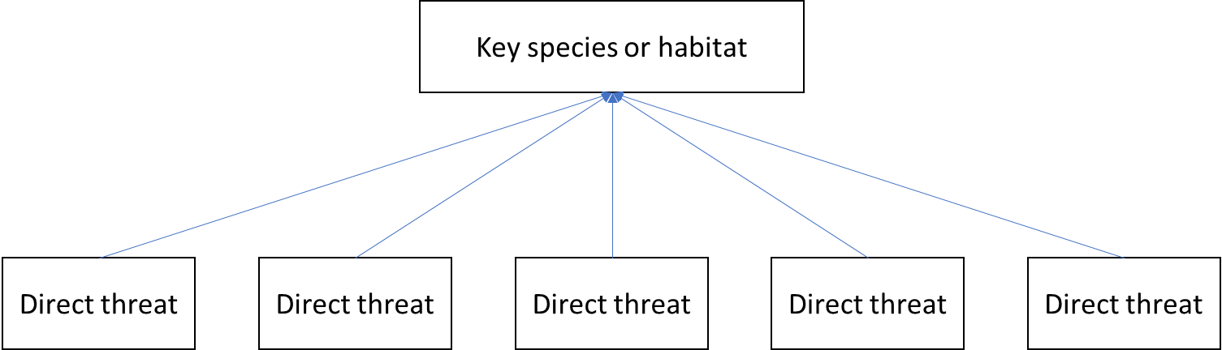

What's driving each of these direct threats?

To understand why these threats are happening, it may be important to take some time to understand what is causing these threats to happen.

*Option 1*

You could map backwards from each direct threat to create a 'tree' of indirect threats. For each new step ask why the issue is happening or what's driving it until you reach a potential intervention point.

**When doing this, it's also helpful to note down the information used to inform your thoughts so that you are confident in your assessment of the situation.**

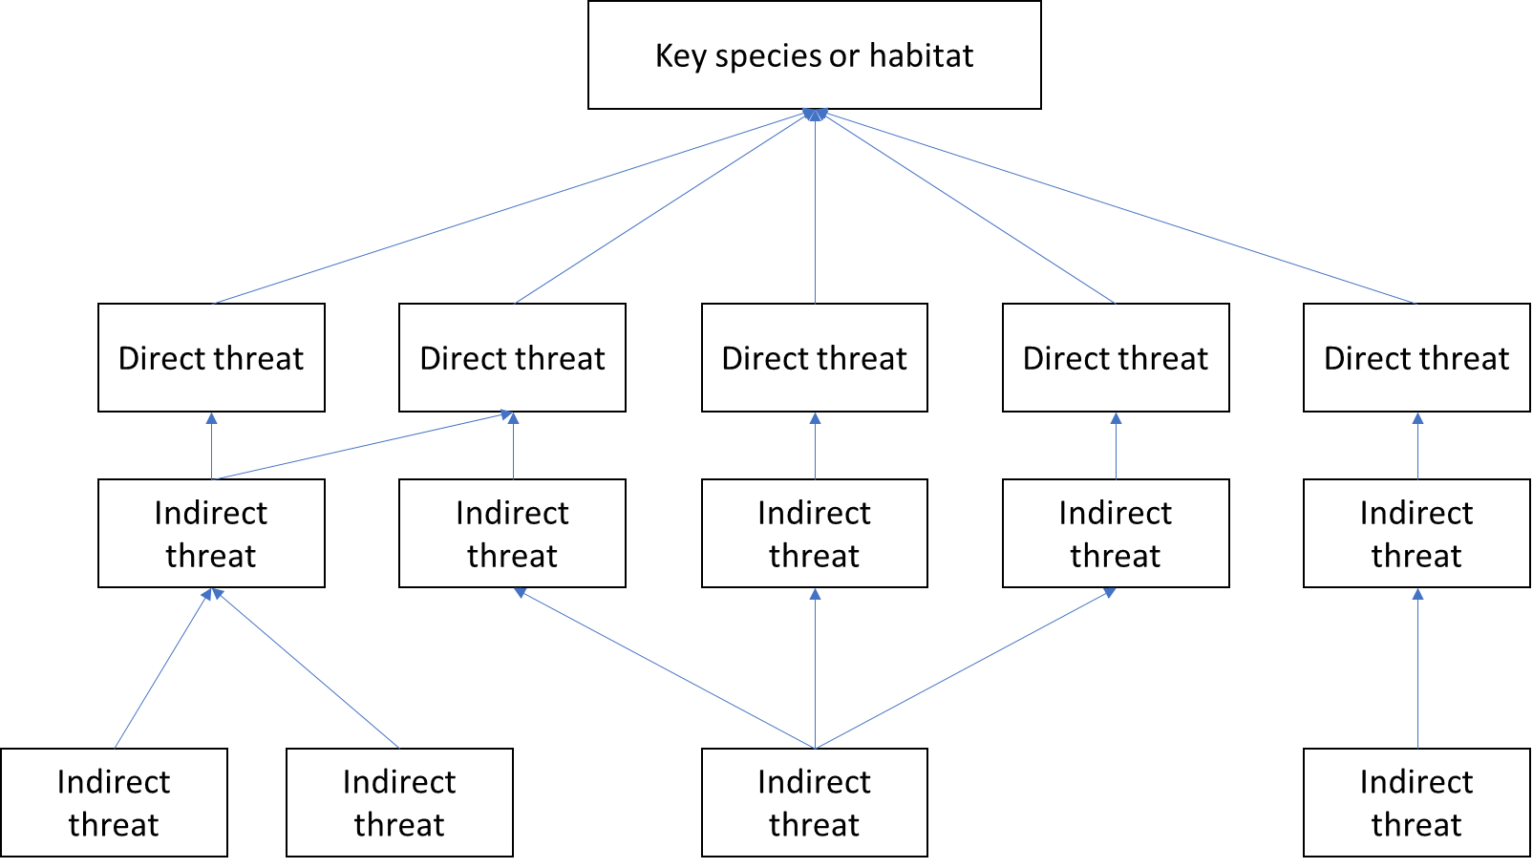

*Option 2*

Alternatively, you may wish to think about the actors or factors that might be causing the threats, and brainstorm these for each of the direct threats. For example:

* **Individuals** - do individuals' living situations influence these threats? If so, who and how?
* **Institutions** - do government bodies or community organisations influence these threats?
* **Systems** - do policies, rules, regulations, and public opinion influence these threats?

Then for each of these causes consider what the barriers to changing these causes are.

*For example, a cause of unsustainable extraction of a specific species could be that individuals living within the national park have no other source of timber for constructing homes. A barrier to change might be that income-levels make purchasing timber difficult.*

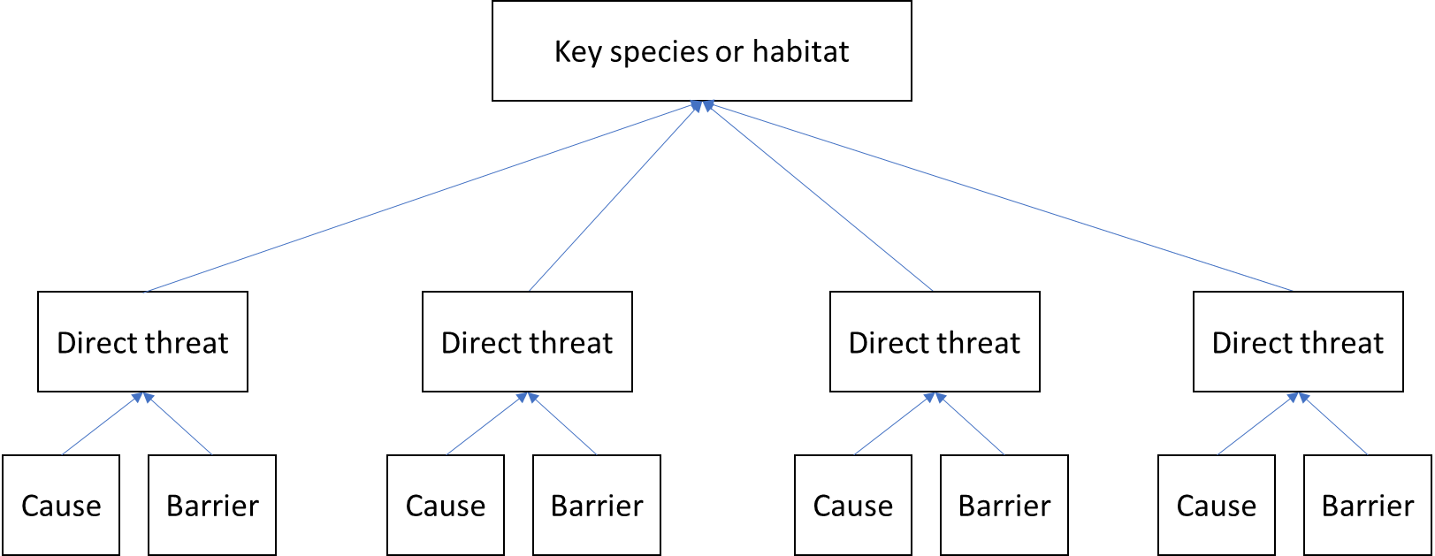

How significant is each of these threats to your biodiversity target?

Understanding how significant each threat could be is important for deciding where to focus your efforts.

*Threat ranking*

You could use a threat ranking exercise similar to the table below to help determine how significant each threat is. If you are working with a number of different species, each of which face different threats, you may want to run this exercise for each of them individually.

*Task*

In a table, complete each box, with a row for each threat, noting down your understanding for the scope, severity and irreversibility of impact of that threat.

|  |  |  |  |  |  |
| --- | --- | --- | --- | --- | --- |
| ***Direct threat*** | ***Scope of impact*** | ***Severity of impact*** | ***Irreversibility of impact*** | ***Final assessment*** | ***Total score*** |
|  |  |  |  |  |  |
|  |  |  |  |  |  |
|  |  |  |  |  |  |
|  |  |  |  |  |  |

*An example of this table is available in the resource document*

**Scope of impact** - Is it a widespread problem affecting a lot of your site or species of interest? Is it likely to be a persistent issue longer term?

**Severity of impact** - How serious are the impacts for the biodiversity target? e.g. would they negatively impact a large part of the area or species group?

**Irreversibility of impact** - How difficult would it be to reverse the impacts of this threat?

Document the information informing your thinking and where it's come from.

Allocate a score for each criteria, using the following scale: 1 = low, 2 = medium, 3 = high, 4 = very high

Then add up scores for each of the direct threats.

**Threats**

* Can your team & partners do anything about the main threats facing your conservation targets?
* Will addressing these threats be significant in terms of delivering on your vision?
* Will there be consequences if these threats are not addressed?
  + Will it still be an issue in a few years’ time?

**What you could do or continue to do**

* Where might you make the most difference?
* Do you have the necessary expertise?
* Are there other organisations you need to work with?

**What you aren't well placed to do**

* What options, strategies or approaches are you deciding not to do and why?

**Stage 6: Develop a solution tree**

*Aim*

The aim of this stage is to develop a solution tree for how the project will achieve the vision of stage 1 and address the threats outlined in stage 6.

*Outputs at end of stage*

* A solution tree for how the project will achieve its vision
* A list of possible solutions that address the threats
* A prioritised list of activities that could be implemented by the project

*Who should be involved?*

* Project team
* Discussion Leader
* Scribe

*Process*

There are two options for how your team can develop a solution tree for the project:

**Option 1. Backwards mapping**

Using the threat tree developed in stage 6, go through each direct threat and turn them into a positive statement i.e. when the problem is solved.

At the higher level these positive statements are often referred to as outcomes and are often outside the direct control of the project. Lower-level positive statements are referred to as outputs and are directly affected by potential activities that the project can implement.

For each outcome there may be several activities that would lead to the outcome, for example, if a problem is “bad soil erosion”, the outcome could be “increased soil stability” there will be many activities that can be taken to reach this outcome, for example, planting appropriate trees or crops, halting logging, etc​

​

It may be useful at this point to define which of the outcomes the project is well-placed to or would like to work towards and which it will not attempt to tackle.

Repeat with each of the outcomes relevant to the project. You should continue backwards mapping until you reach activity/intervention points – where the project can directly act upon. Repeat as needed with each outcome.

If time and resources permit, there is great value in doing this together with stakeholders, to gain not only their knowledge but also ownership on the process. This will improve the likelihood of your project being impactful and sustainable.

It is very unlikely you will be able to include all the outcomes you have identified and deciding what threats you will address at this time is part of your project strategy.​

**Option 2. Forwards mapping from potential interventions**

Rather than directly mapping solutions to the threats and drivers unpacked in stage 6, you can initially review the threats as a whole and note down any interventions that they think of as well as combine with any that they had in mind already.

Next plot out how you would expect each intervention to achieve the desired impact:

* Starting from the direct output for what that intervention would achieve,
* Followed by what outcome that output would cause,
* Finally, how that outcome would achieve the overall impact

As you go through each intervention, you may find that some activities have similar or the same outcomes/outputs. This is to be expected and will help to simplify your theory of change diagram.

You may find that some activities do not lead to the overall impact. For these it may be that:

* The activity is not appropriate for the project
* The impact statement needs to be adapted to reflect that activity’s impact

**Reviewing the solution tree**

Whether you did option 1 or 2, it is important that you prioritise which activities the project should take forward. This depends on:

* The likelihood of the activity solving the problem
* The likelihood of the project team being able to implement that activity
* If other stakeholders are already implementing that activity

**Stage 7: Develop a Theory of Change diagram and narrative**

*Aim*

Develop a Theory of Change (ToC)

*Outputs at end of stage*

A ToC diagram and narrative

*Who should be involved?*

* Key members of the project team
* Discussion Leader

*Process*

Developing the ToC is split into 3 steps:

* Step 1- Clarify your impact statement
* Step 2- Test the logic and check assumptions
* Step 3- Write up narrative to support ToC diagram

*Step 1- Clarify your impact statement*

For this step, start by reviewing the vision statement/s of the project that you have developed in stage 1 or a previous vision/impact statement that your project has developed.

Next develop an impact statement that captures the specific lasting change that you expect the project to cause/contribute by the programme’s intervention.

This impact statement should be long-term so try to not focus on short term outputs, but at the level of long-term project success.

*Step 2- Test the logic and check assumptions*

Once you have plotted out how each activity will create the intended impact, each chain should be reviewed to check the logic is correct and capture what assumptions you are making at each step.

For both the impact pathways and the assumptions, consider:

* Why did you think that ‘x’ will lead to ‘y’?
* What might hinder this from happening (e.g. costs, opposing views, lack of trust/capacity/technology, people losing assets, etc)?
* What are the gaps in your ToC? Are there any missing links?
* Who else might need to be involved? Who else can you connect with who can aid in your progress towards your desired impact?

Looking at the pathways again, are there better ways of getting to your goal?

For each key assumption, consider:

* If evidence and experience tell us these assumptions are likely to be true or not
* How serious the consequences are if the assumptions are found to be untrue

*Step 3- Write up narrative to support ToC diagram*

Once the ToC diagram has been agreed, it is important to capture a written document of it to explain the logic the team have used within the model.

*How to use ToC once developed*

Once a ToC is developed, there are ways that it can be instantly used:

* Including as part of a proposal to describe to the donor how you expect change to happen
* Reflecting on the project and understanding how the activities that you plan to do will achieve your shared vision
* Help to decide what do you need to monitor/evaluate to ensure that the project is achieving what you planned.

After a period of time it will be necessary to review the ToC to see whether the logic still holds. Please refer to the section on reviewing and updating the ToC for more information.

**Review and update a ToC**

*Aim*

Adapt the ToC as the project changes or the context changes

*Outputs at end of stage*

A ToC that continues to be relevant and logical

*Who should be involved?*

* Key members of the project team
* Discussion Leader

*Process*

If there is significant change, the logic of a ToC can breakdown and depending on how much has changed, the previous ToC can be adapted or in more extreme circumstances, a new ToC developed.



*Figure 1. Steps to consider when reviewing the ToC*

The reviewing of the ToC is crucial. As the activities being implemented by the project are based on the logic of the ToC in how they expect change to happen.

The focus of ToC reviews is to understand whether the logic that you developed initially still holds true. The following questions can encourage discussion and focus for where the ToC needs to be adapted:

* + Do you have new information that changes your thinking for how your interventions will make an impact?
  + Does the data you have collected through monitoring and evaluation indicate that the interventions are having greater or less of an effect?
  + Have you realised other activities are needed to achieve your vision?
  + Did you have the appropriate stakeholders involved in the development of the previous ToC?
    - Community stakeholders
    - Cross-cutting teams
    - External experts
  + Do the assumptions that you made in the initial ToC still make sense?

It can be helpful to start reviewing the ToC from the activities/outputs, seeing whether any activities/outputs need to be added and then work forwards, reviewing whether the logic still holds and any assumptions made.

**Simplifying a ToC**

*Aim*

Simplify the ToC to be understandable and usable

*Outputs at end of stage*

A ToC that continues to be understandable and usable

*Who should be involved?*

* Key members of the project team e.g. project lead
* Any persons involved in developing the original ToC
* Discussion Leader

When a ToC becomes too complicated, it can often mean that the reasons for creating a ToC, such as explaining to an external audience/setting out a plan for monitoring and evaluation, are not fulfilled. When this occurs, the following actions can assist to simplify it:

* Select 3 or 4 main “outcomes” that the project needs to achieve in order to create the final impact/vision.
* Select 4 or 5 key activities/outputs for each outcome
* Check if there is any repetition in the activities/outputs that can be combined
* Remove any one-off activities

**References**

CMP, 2020. Open Standards for the Practice of Conservation Version 4. <https://conservationstandards.org/wp-content/uploads/sites/3/2020/10/CMP-Open-Standards-for-the-Practice-of-Conservation-v4.0.pdf>

FFI, 2019. Our Strategy 2019-2023. <https://www.fauna-flora.org/app/uploads/2020/03/FFI-Strategy_2019-2023.pdf>

FFI, 2021 Conservation Report 2020. <https://www.fauna-flora.org/app/uploads/2021/11/FFI_2020_Conservation-Report.pdf>