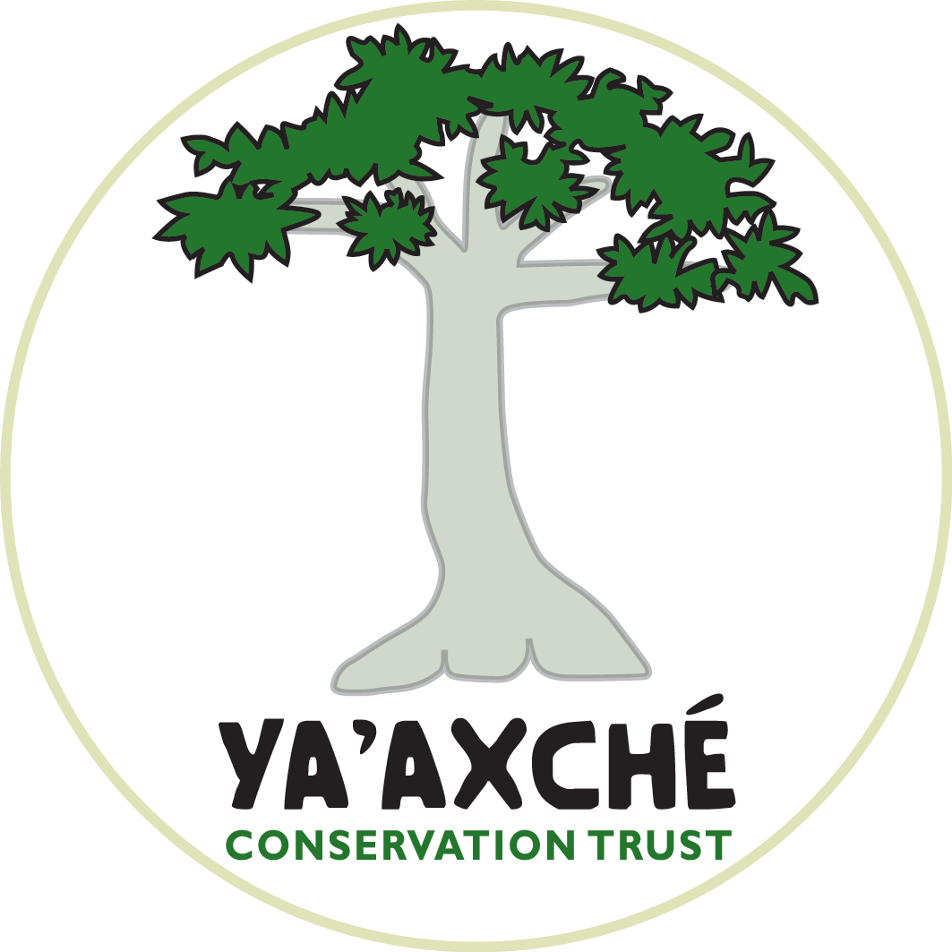

Welcome to Ya’axché!

This is an orientation checklist for a self-guided introduction to Ya’axché and to your position. Please take the first two weeks after your arrival to complete the activities listed below and to learn about the organization, our projects, and the context in which we work. Although the activities are listed in a logical progression, they do not have to be completed in this order. You can go through the checklist at your own pace; however, you are also the one responsible for scheduling the various discussions with relevant staff and site visits. Each activity indicates the person whom you should contact about each activity.

Orientation Plan for: Start Date:

General Introduction | Contact Person | √ When Completed
Logistics
Receive and review Ya’axché’s Handbook and Volunteer Manual | Self-Directed
Complete and sign volunteer forms | Self-Directed
Read staff bios on Ya’axché’s website | Self-Directed
Prepare personal bio and email to Website administrator | Self-Directed
Receive your email log-in and set-up your email system | Self Directed
Ensure that your email is connected to Ya’axché’s online calendar and review it (for example monthly staff meeting dates). | Self-Directed
Receive and review a folder of management plans important for Ya’axché’s work | Self-Directed
Punta Gorda Office
Office tour and introduction to general office procedures | Ekat (Operations Manager)
Connect to the server and receive a virtual tour | Ekat (Operations Manager)
Golden Stream Field Center
Golden Stream Field Center general tour | Moon (Head ranger) or any field ranger
Tour of the greenhouse and the nursery | Kenny (Extension Officer)
Instruction on the use of solar power system and internet at the Field Center | Moon (Head ranger)
Health, safety, and wellness | Ekat (Operations Manager)
Who is Ya’axché? | Contact Person | √ When Completed
History of the organization | Barts (COL Program Manager, co-founder of Ya’axché)
Overview of Ya’axché’s governance: Board, staff organogram, 2012-2014 Strategy, 2012 Operational Plan, ILM approach in the Maya Golden Landscape | Ekat (Operations Manager)
Protected Areas Management Program
Introduction to the PAM program | Lee (Protected Areas Manager)
Go on a patrol in Golden Stream Corridor Preserve | Moon (Head ranger)
Visit Bladen Nature Reserve base and attend a day patrol (as time permits) | Moon (Head ranger)
Overview of research and biodiversity monitoring activities | Maarten (Research Officer)
Participate in biodiversity transect monitoring (if time permits) | Maarten or Moon
Find out about Ranger for a Day Program | Moon or any field ranger
Some rangers are trained field parabiologists. Find out who is an expert birder and who is on the freshwater monitoring team. | Field rangers
Review management plans (not every detail, but to understand the overall scope of information in all): BNR management plan, GSPPL management plan, Integrated Landscape Management strategy for the Maya Golden Landscape, MMM-CAS | Self Directed
Review field guides for mammals and birds of Belize | Self Directed
Community Outreach and Livelihoods Program
Introduction to the COL program | Barts (COL Program Manager)
Find out about Ya’axché’s farmer extension work (agroforestry, beekeeping, vegetable gardening). Try to combine this with a visit to a farm. | Kenny (Extension Officer)
What is TADA? | Sergio
Find out about Ya’axché’s outreach program (school visits and school field trips, birding clubs, women's groups , scholarship program, community meetings, summer camp) | Julio (Education and Outreach Officer)
COL Monitoring and Evaluation | Ekat
Orientation to Position (Development Officer) | Contact Person | √ When Completed
Review Ya’axché’s Fundraising Strategy | Self-Directed
Development Workshop | Ekat
Completed: ________________________________ (signature and date). Any comments below:

